NEIGHBORHOOD CULTURAL EVENT & TALENT SHOWCASE
@CREATIVITY THINK (9483175986/7019689991)

ABSTRACT:
Neighborhood Cultural Event & Talent Showcase is a web-based platform designed to facilitate the organization, registration, and management of local cultural events and talent exhibitions. Participants can register for performances, view allocated time slots, upload media, and participate in voting. Administrators can create events, approve participants, schedule performances, monitor voting for authenticity, and analyze overall event statistics. Built using Django and Django REST Framework for backend processes, and React with Redux and axios for frontend interactivity, the system ensures streamlined event management, secure voting, and real-time analytics for community engagement..

INTRODUCTION OF THE PROJECT:
Community and neighborhood events often face challenges such as disorganized registrations, scheduling conflicts, fraudulent voting, and lack of consolidated performance analytics. Traditional manual methods for managing talent showcases are inefficient and error-prone. This platform addresses these issues by providing a centralized digital solution for event creation, participant management, performance scheduling, secure voting, media galleries, and dashboard analytics. The system enhances community participation, ensures transparency, and provides administrators with tools to effectively manage cultural events..

PROJECT OBJECTIVES:

• Enable users to register for neighborhood cultural events
• Allow participants to browse events and submit performance entries
• Allocate performance slots with clear scheduling
• Facilitate post-event voting and feedback collection
• Provide media galleries for photos and videos
• Offer administrators tools to approve participants and manage event schedules
• Implement secure voting mechanisms to prevent fraud
• Provide dashboards for analytics on participants, votes, and popular performance categories
• Allow export of event summaries and reports

PROBLEM OF THE STATEMENT:
Organizing neighborhood cultural events manually often leads to registration errors, scheduling conflicts, inconsistent feedback collection, and difficulty in analyzing participation or performance popularity. This system resolves these challenges by providing a digital framework for event registration, performance management, secure voting, media sharing, and comprehensive analytics, ensuring a smooth, fair, and transparent process for both participants and administrators..

MOTIVATION OF THE PROJECT:
• To simplify cultural event registration and participant management
• To provide a secure and reliable voting mechanism
• To streamline scheduling and performance order management
• To offer visual galleries of event performances
• To provide administrators with analytics for better decision-making
• To enhance transparency and reduce manual errors
• To promote community engagement and participation
• To allow event summaries and reports to be exported for record-keeping

BLOCK DAIGRAM OF PROJECT:

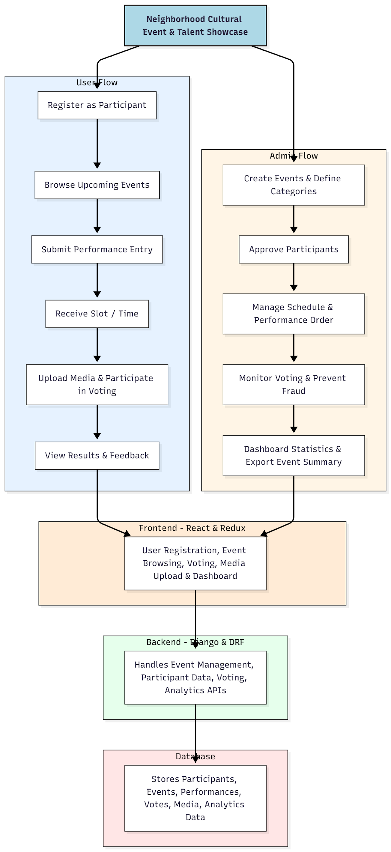

WORKING OF THE PROJECT:
Participants register on the portal and browse upcoming cultural events. They submit performance entries (song, dance, drama, etc.), receive allocated time slots, and can upload related media post-event. Voting opens after the event, with one vote per authenticated user to prevent fraud. Administrators create events, approve participants, manage performance schedules, monitor voting activity, and analyze engagement metrics. Dashboards display statistics such as participant count, votes per category, and popular performance types. Event summaries and analytics reports can be exported for documentation and future planning. The backend manages all data processing, secure voting, media handling, and analytics calculations..

SOFTWARE REQUIREMENT:
- Backend:
  - Python 3.x
  - Django
  - Django REST Framework
  - SQLite/PostgreSQL
- Frontend:
  - Node.js and npm
  - React.js
  - Axios
- Development Tools:
  - Visual Studio Code
  - Postman (for testing APIs)
  - Git/GitHub (for version control)
- Server/Deployment (Optional):
  - Gunicorn, Nginx, or Heroku/AWS for hosting

ADVANTAGES OF THE PROJECT:

• Streamlines cultural event organization and participant registration
• Secure and fair voting system
• Efficient management of schedules and performance order
• Real-time analytics and dashboard insights
• Easy media uploads and gallery management
• Exportable event summaries and reports
• Enhances community participation and engagement
• Reduces manual errors and administrative workload

APPLICATIONS OF THE PROJECT:
• Apartment or neighborhood cultural events
• School or college talent showcases
• Community halls and local gatherings
• Corporate or NGO cultural programs
• Town or village event management

REFERENCES:

- Django REST Framework Documentation — Django Software Foundation. Django Documentation. Available: https://docs.djangoproject.com/
- Django REST Framework. DRF Documentation. Available: https://www.django-rest-framework.org/
- React. React Official Documentation. Available: https://reactjs.org/docs/getting-started.html
- Redux. Redux Documentation. Available: https://redux.js.org/introduction/getting-started
- PostgreSQL Global Development Group. PostgreSQL Documentation. Available: https://www.postgresql.org/docs/
- MySQL. MySQL Reference Manual. Available: https://dev.mysql.com/doc/
- Git. Git Documentation. Available: https://git-scm.com/doc
- Node.js. Node.js Documentation. Available: https://nodejs.org/en/docs/
- Axios. Axios Documentation. Available: https://axios-http.com/docs/intro
- Socket.io Documentation – https://socket.io/docs/

